**EXECUTIVE REPORT**

**Industry - Corporate Hospital**

**Salary Policy of the company**:

* Based on the data, Job category 3 employees earn the highest salary compared to 1,2. Thus, we can infer that they are working in a high paying field in the hospital (Eg: Specialist Doctors like surgeons, neurologists; Board members).
* Gender is negatively correlated with salary and based on the data, we can see that generally Male employees are paid more compared to Female. Male_salary : 10,691,980 (258 Male) , Female_salary : 5,622,895 (216 Female) [Appendix - Figure 1.0]. As we can see, there is a huge wage disparity between Male and females. Also, the sample size is quite similar and we have just 42 more males in our dataset. But, the sum total of male salaries is around 5,069,085 (5 Million) more than females which is huge.

**Business Recommendations:**

* The female employees belonging to Job Category 3 are not earning as much as the male employees. There should be no wage disparity between Male and Female employees in the organization and based on the Job category the salaries should be decided and not based on Gender.
* Most female employees belong to Job Category 1 and none belong to Job Category 2. [Appendix - Figure 2.0]. Maybe, the company can hire more female employees who can work as Assistant doctors, managers and as marketing specialists in the hospital. Also, Job Category 3 has few females compared to male. The company prefers having more male employees in the high paying positions but this should be changed and there should be gender equality across all the 3 categories.
* People with more years of Education are paid more [Appendix - Figure 3.0]. This is a really good policy by their organization and I support this approach. However, they can also test people who have slightly less years in education with the people who have more and if they find their skills, competency level similar, they can pay the people with less education a higher salary, comparable to the ones with more education under their belt.
* Based on the descriptive statistics, it was found that out of 474 employees, only 104 belong to the minority class (which is approximately 22%). The company should hire more employees from the minority section and have a balance between minority and non-minority in their organization.
* Of the minority class, they occupy most positions in the Job Category 1 (87 employees) which is low paying compared to the other fields. Maybe, the company is hiring nurses, male nurses from people belonging to minorities. Moreover, only 13 employees belong to Job Category 2 and only 4 employees belong to Job Category 3 from the minority class. [Appendix - Figure 4.0] The company can alter its hiring criteria and get more people from minority classes who can fall under the high paying Category 3. [Specialist Doctors, Executives, Board members,etc.]
* [Appendix - Figure 5.0] shows the pair plot for Salary, Job_Category, Experience based on the Gender.

**NOTE - Gender has been encoded { Male -0, Female - 1} for correlation, regression and graphical analysis.**

Python: [https://colab.research.oogle.com/drive/1x5JmB064js5KVrJEqmhVoqAiX9axe9wu?usp=sharing](https://colab.research.google.com/drive/1x5JmB064js5KVrJEqmhVoqAiX9axe9wu?usp=sharing)

**APPENDIX [Python]**

**Figure 1.0**

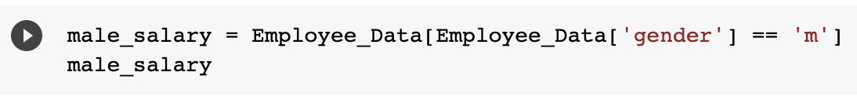

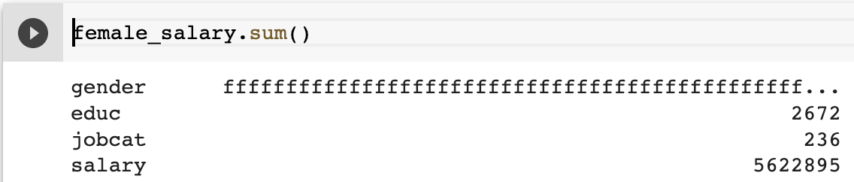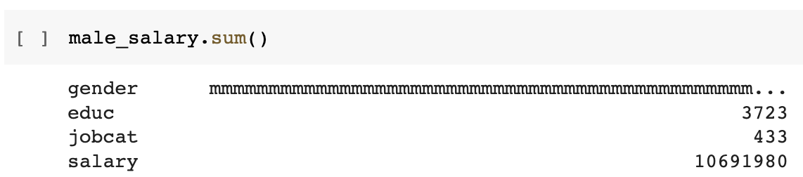

**Figure 2.0**

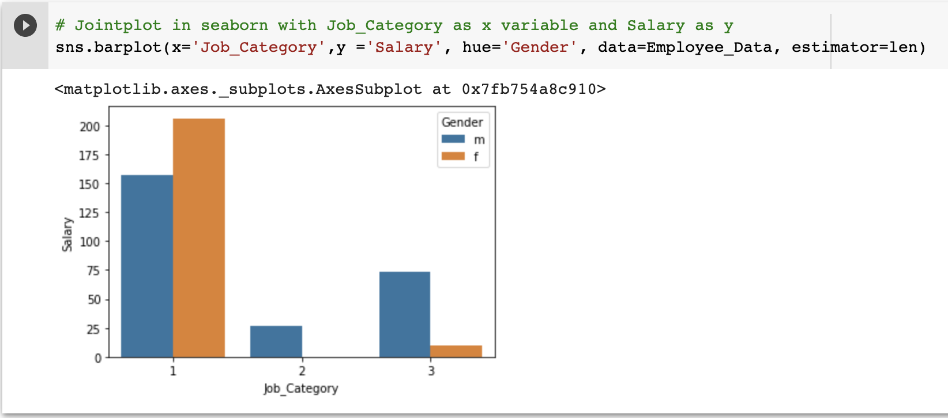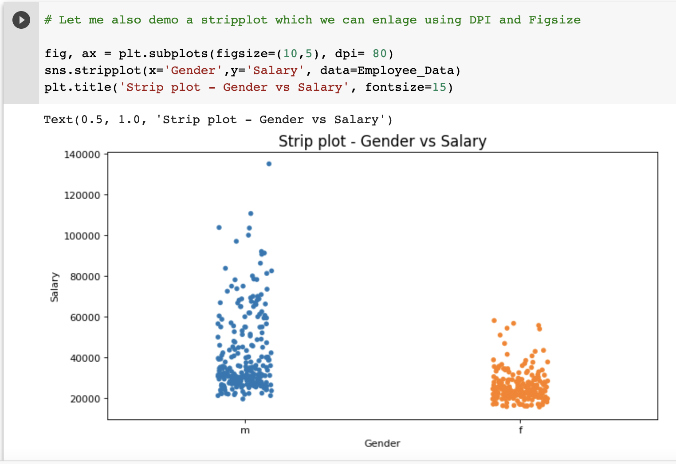

**Figure 3.0**

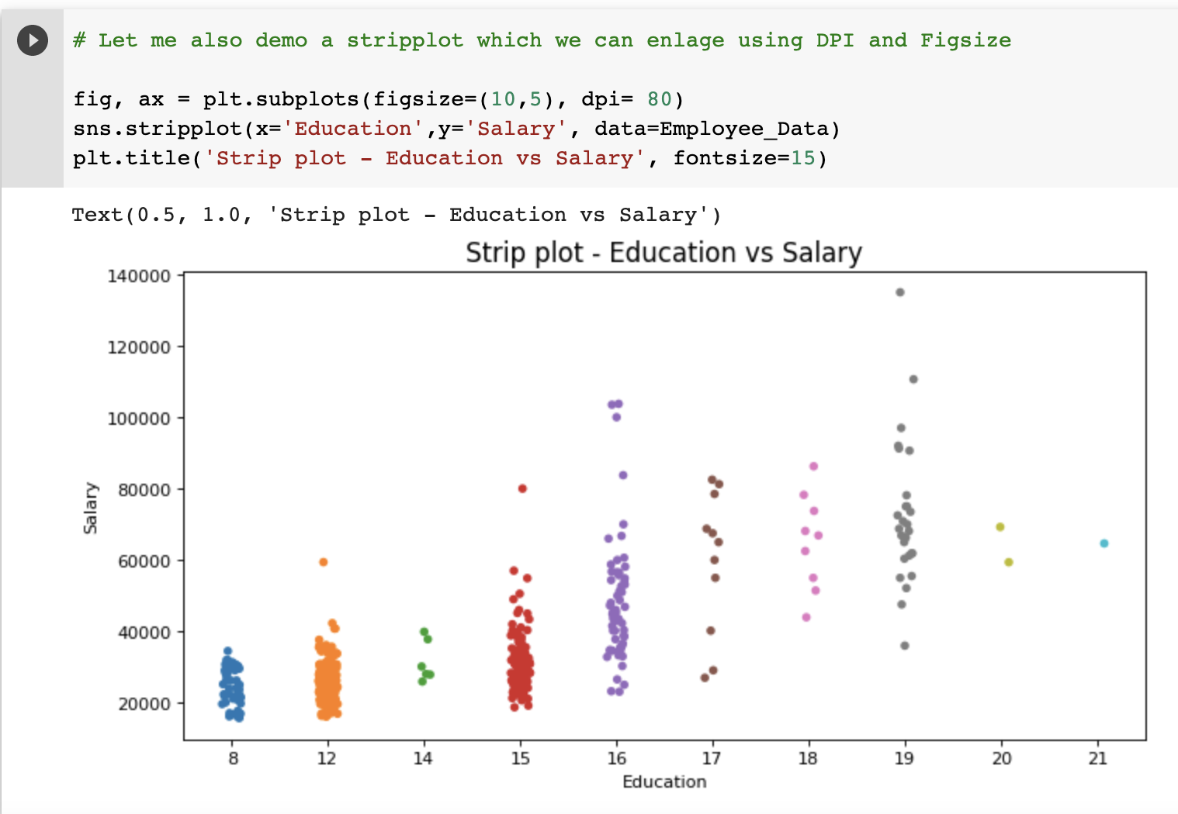

**Figure 4.0 (Minority = 1 belonging to Job_Category = 1 has 87 entries)**

Similarly, Minority in Job_Category 2= 13 entries, Minority in Job_Category 3= 4 entries

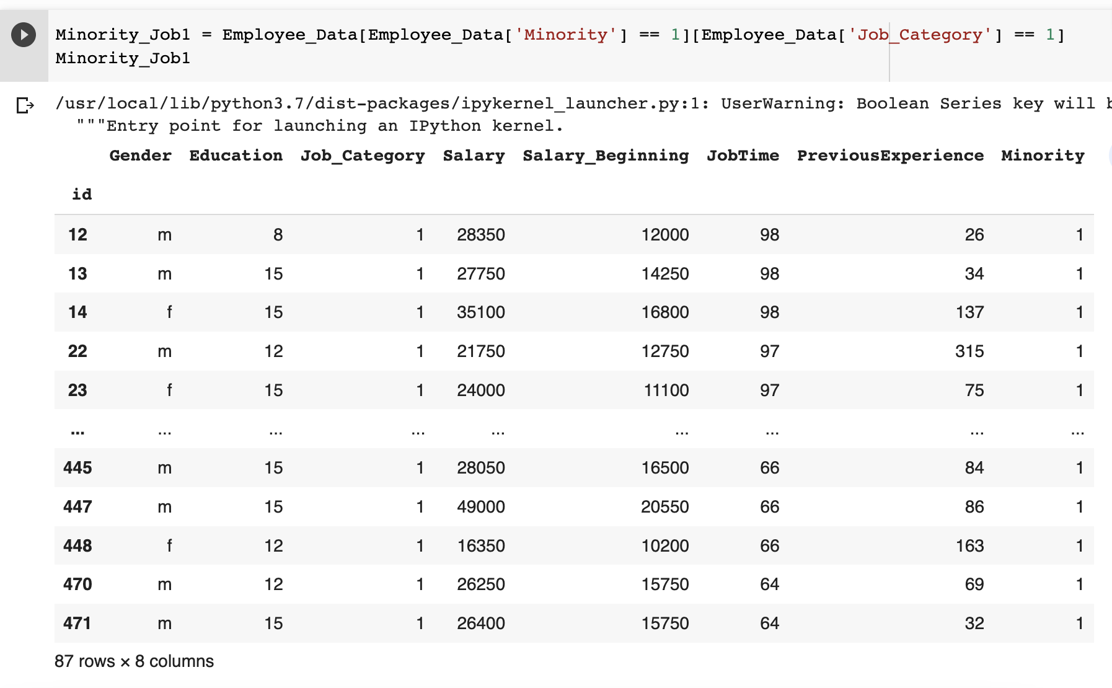

**Figure 5.0 (Pair plot - Based on the Gender)**

